**ASSIGNMENT 6.2**

**on**

**Testing**

**Submitted by:**

**Haseebullah Shaikh (2303.KHI.DEG.015)**

**Faiza Gulzar Ahmed (2303.KHI.DEG.001)**

**and**

**Aqsa Tauheed (2303.KHI.DEG.001)**

**Dated:** 23rd May 2023

**Given add functions**

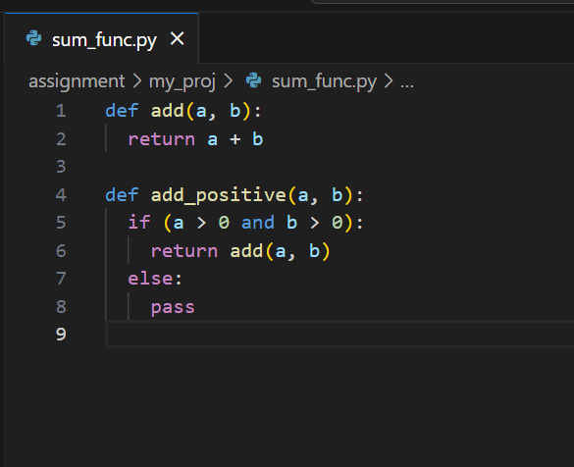

**Tests implementation**

Tests are implemented in way to achieve 100% code coverage, given tests ensures

* Each statement in code is executed
* Conditions works properly which is tested by trying all the condition combinations.
* 100% code coverage by implementing branch testing, each function is evaluated as true as well as false.

**Implementation code**

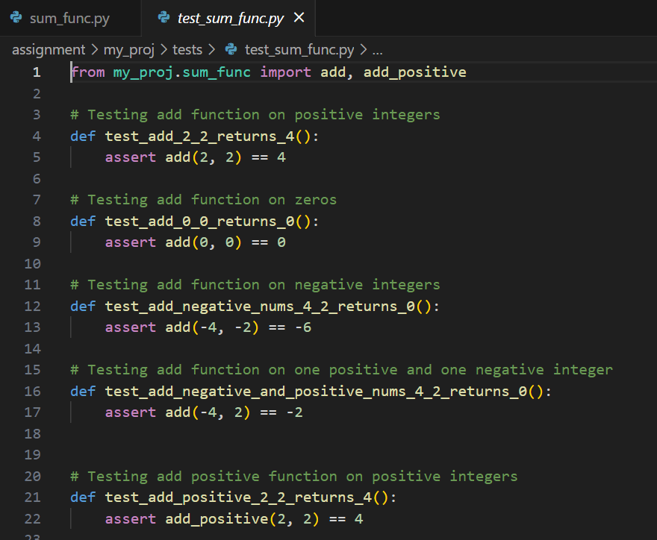

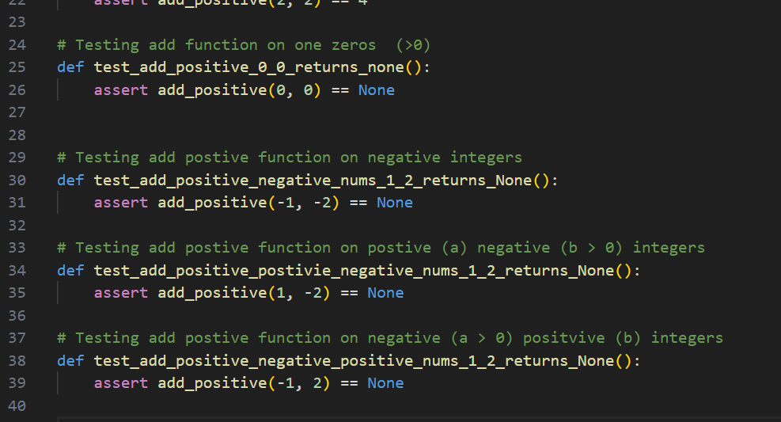

**Testing coverage results**

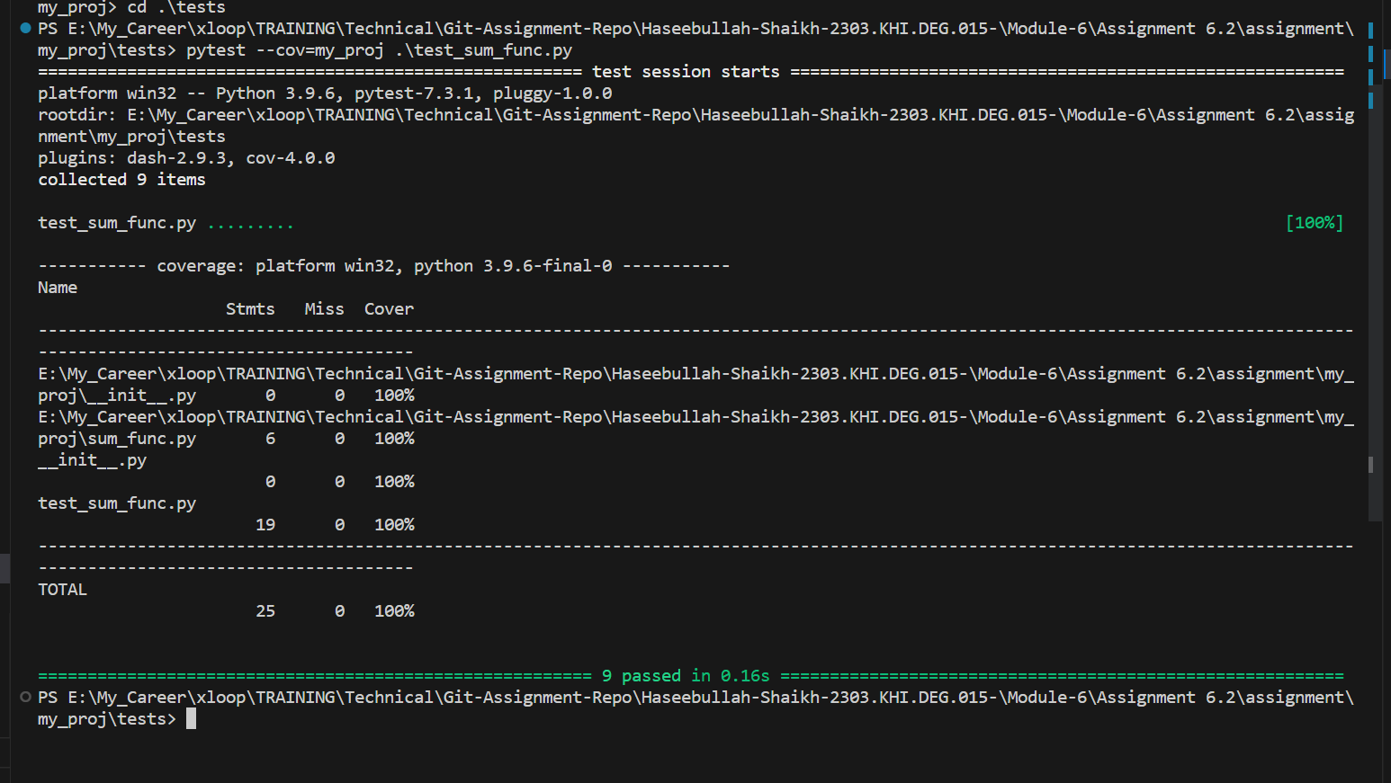

**The End ☺**